Laravel installation

* Install laravel, insomnia, git

For creating model with controller and api, and also migrating it:-

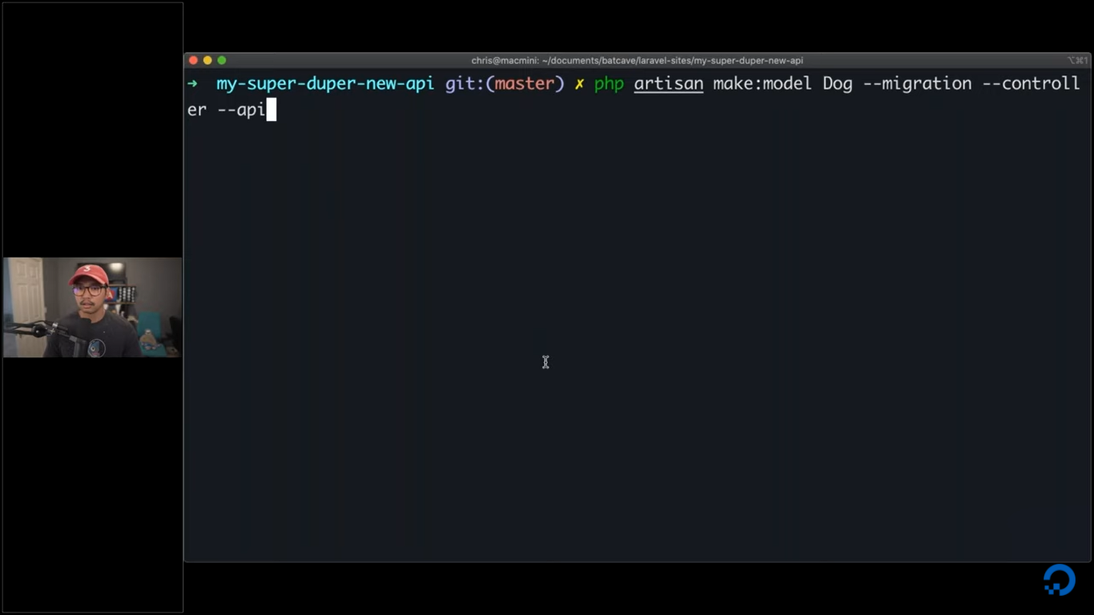

Api functions in laravel:-

1. Get
   1. Displays all the record in the db
   2. Syntax:- return TableName::all();
2. Post
   1. Insert the data in db
   2. Header
      1. Content-type= multipart/form-data
   3. Multipart form
      1. Add the data to store
   4. Syntax:- return TableName::create($request->all());
3. Update
   1. Update the data in db for the specific id
   2. Syntax:-

$post=TableName::find($id);

$post->update($request->all());

return $post;

* 1. Json
     1. Example:-

{

"EntityName": "Text goes here…"

}

1. Delete
   1. Delete the data for the specific id
   2. Syntax:- return TableName::destroy($id);

Validation:-

* + - 1. $request->validate(['EntityName' => 'required|unique:posts|max:255']);
      2. Refer the documentation provided on larval website for validation:- <https://laravel.com/docs/7.x/validation>

For Versions:-

1. Use Route Prefixes
2. Example and Syntax:-

Route::name('admin.')->group(function () {

Route::get('users', function () {

// Route assigned name "admin.users"...

})->name('users');

});

1. Documentation link:- <https://laravel.com/docs/7.x/routing#route-group-prefixes>

Casting datatype:-

1. Documentation Link:- https://laravel.com/docs/7.x/eloquent-mutators#attribute-casting